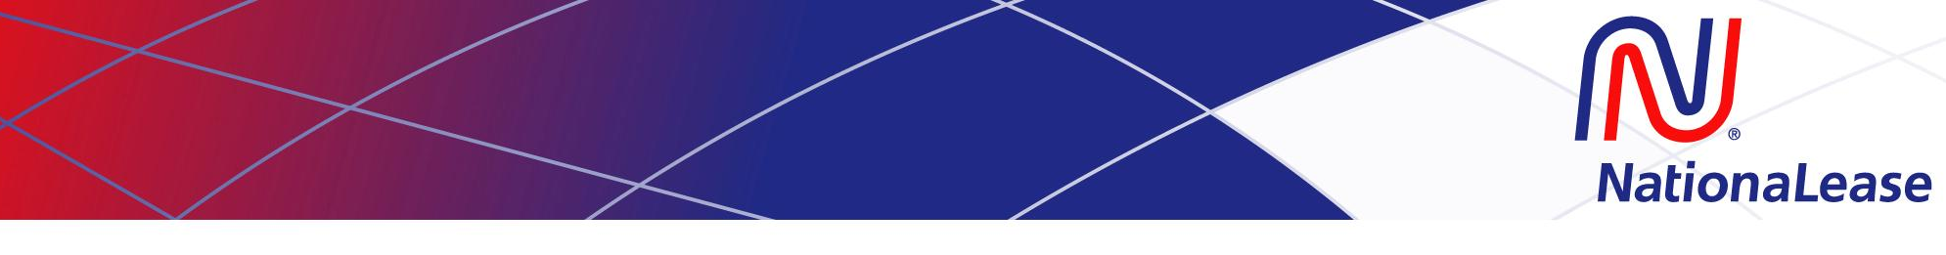

Introduction to Full Service Leasing

June 7-8, 2017 Hyatt Lisle, IL

Is it time to jump start your full service leasing program? Plan to join us …

Day One (8am-5pm). The seminar’s first day kicks off with a dynamic review of sales & marketing, including a short history of full service leasing, knowing your product lines, branding, prospecting & networking and proposals. The afternoon gets hands-on with an extensive review of the rating process, step-by-step rating of leases utilizing the NationaLease Member Rate Sheets and competitive group exercises. The rating conversations will undoubtedly continue throughout the evening during the seminar’s group dinner.

Day Two (7:45am-Noon). The seminar’s final day wraps up any rating activities and then dives into useful background knowledge of structuring a leasing company. Topics will include operating a leasing company, operations strategies, leadership & management, financial reporting, credit & insurance and service, purchasing & Human Resources.

Who Should Attend? The program will benefit both entry-level and experienced sales representatives, owners with limited background in full service leasing, and sales managers looking to standardize their operations.

Your Instructor. Bill Hicks, former Director and Chairman of the NationaLease Board—Bill has an extensive background in the leasing industry for over 40 years.

Registration/Fees. Registration fee of $795 per person includes workshop materials, breakfast, working lunches, and dinner on the evening of Day One. Hotel and airfare are not included in your registration fee. Hotel reservations should be made no later than May 16th to guarantee a room at the NationaLease rate. Class size is limited, so don’t delay registering. Note: Full refunds are available upon receipt of written notice until May 16th. After May 16th, a $195 per person charge will be assessed. Infrequently, a workshop must be cancelled due to lack of registration. We reserve the right to cancel/postpone the class, if necessary, up to three weeks before the seminar (you will be notified by e-mail on/before April 28th if cancellation is necessary). We recommend that you do NOT make plane reservations until after April 28th.

Hotel Information. NationaLease Introduction to Full Service Leasing dedicated hotel is the Hyatt Lisle in Lisle, Illinois. Room rate is $110 per night based on single or double occupancy. To make your room reservations, please contact and mention NationaLease as your meeting group:
Hyatt Lisle
1400 Corporetum Drive
Lisle, IL 60532
Phone: 630.852.1234

☐ Please register me for Introduction to Full Service Leasing
Registrant Name: Click here to enter text. Title: Click here to enter text.
Company Name: Click here to enter text.
Location: Click here to enter text.
(include street address, city, state, zip code)
Telephone: Click here to enter text. Cell Phone: Click here to enter text.
E-Mail: Click here to enter text.
Years “Lease Sales” Experience: ☐ 0 ☐ 1 ☐ 2 ☐ 3 ☐ 4 ☐ 5 ☐ 6+
☐Other Sales Exp Click here to enter text. Request Topic: Click here to enter text.
Please e-mail registration to Kelly Kordowski at kkordowski@nationalease.com.

